1) Fetch Stored Procedure

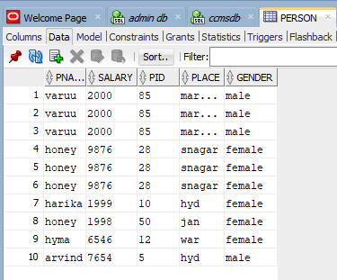

create or replace PROCEDURE PERSONFETCHSP
(
per_cursor OUT SYS_REFCURSOR
)AS
BEGIN
OPEN per_cursor FOR
SELECT *
FROM person;
NULL;
END PERSONFETCHSP;
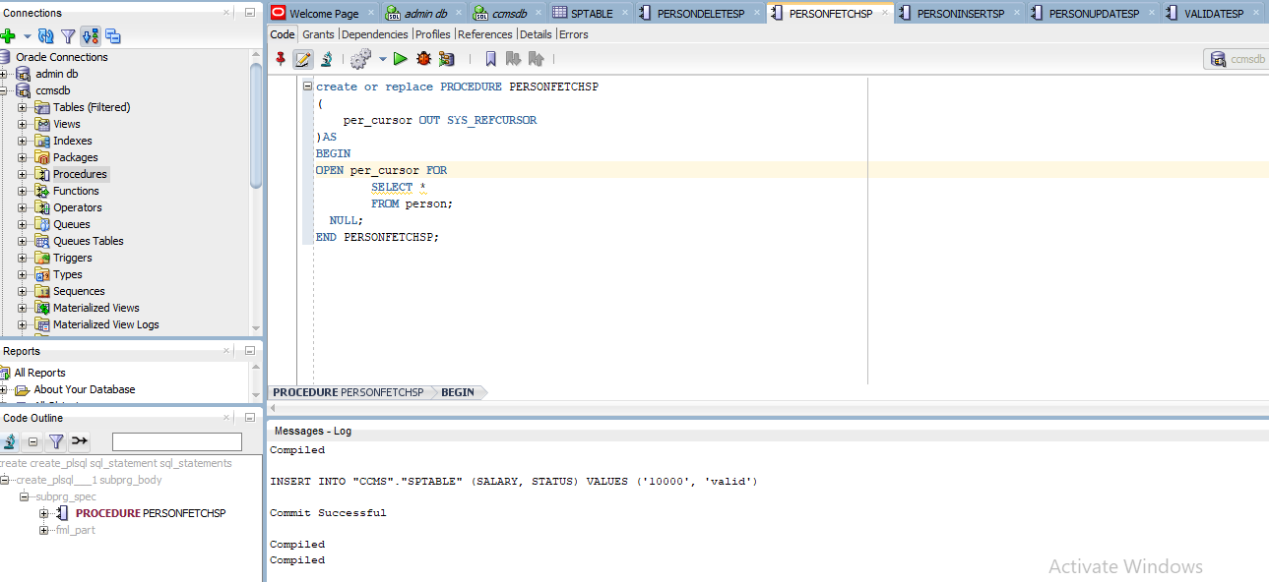

2) Insert Stored Procedure

create or replace PROCEDURE PERSONINSERTSP
(
pname IN VARCHAR2
, salary IN VARCHAR2
, pid IN VARCHAR2
, place IN VARCHAR2
, gender IN VARCHAR2
)
AS
BEGIN
insert into person("PNAME","SALARY","PID","PLACE","GENDER")values(pname,salary,pid,place,gender);
END PERSONINSERTSP;

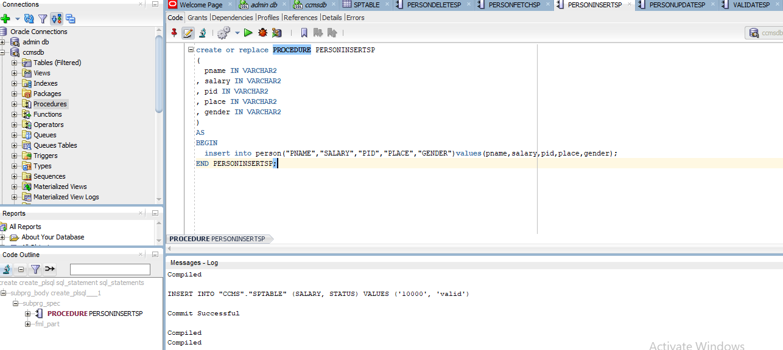
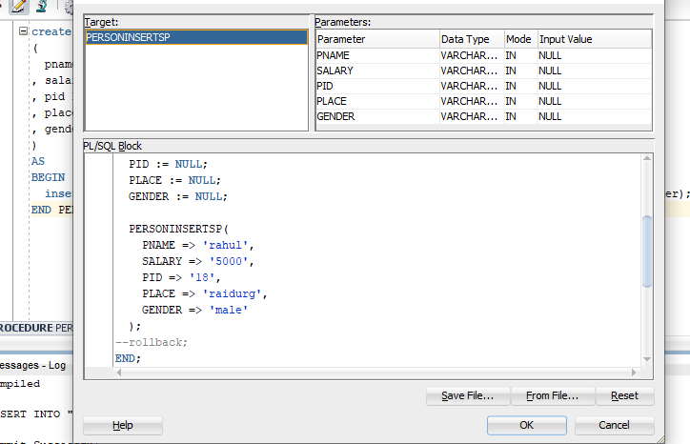

3) Update Stored Procedure

create or replace PROCEDURE PERSONUPDATESP
(
p_pname IN VARCHAR2,
p_salary IN VARCHAR2,
p_pid IN VARCHAR2,
p_place IN VARCHAR2,
p_gender IN VARCHAR2
) AS
BEGIN
UPDATE person
SET pname = p_pname,
salary = p_salary,
place = p_place,
gender = p_gender
WHERE pid = p_pid;
END PERSONUPDATESP;

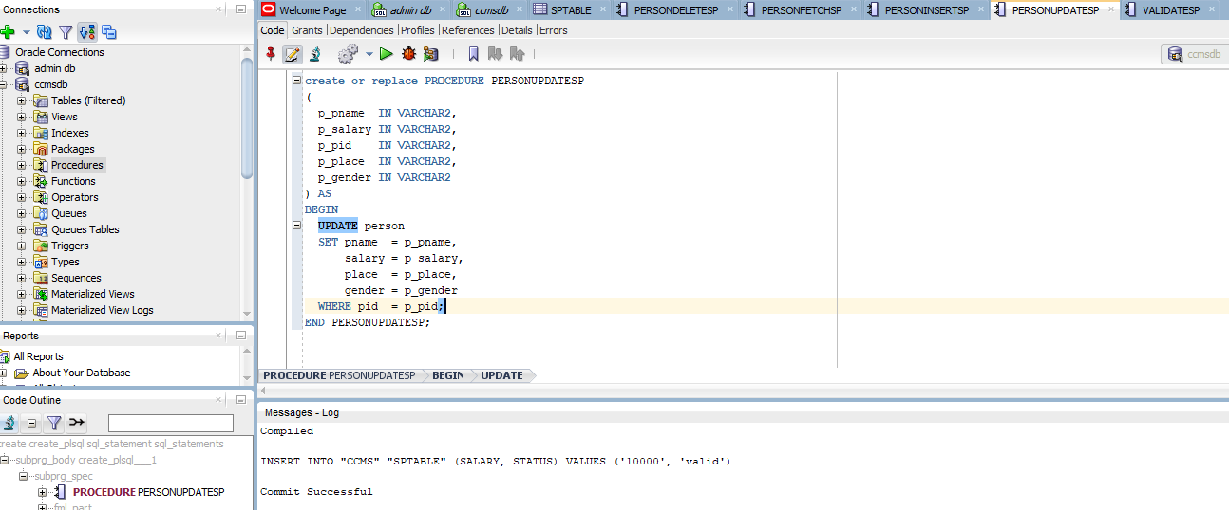

4) Delete Stored Procedure
create or replace PROCEDURE PERSONDELETESP
(
p_pid IN VARCHAR2
)AS
BEGIN
DELETE FROM person WHERE pid = p_pid;
END PERSONDELETESP;

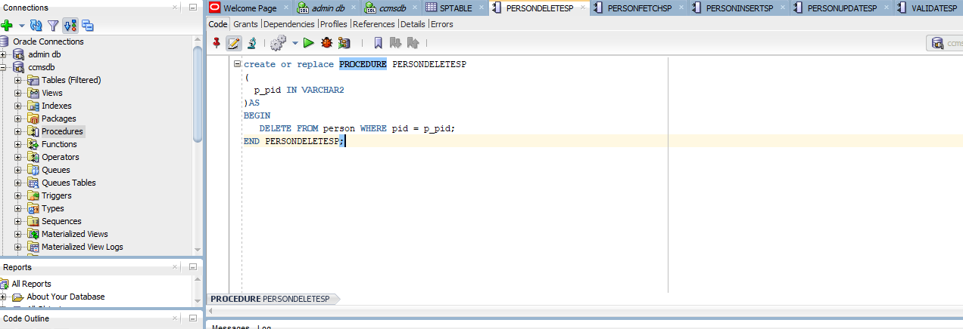

5) Validation Stored Procedure
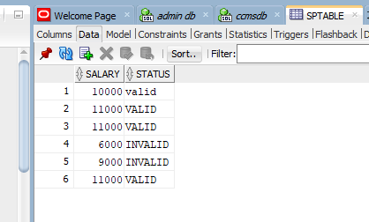

CREATE OR REPLACE PROCEDURE VALIDATESP
(
p_salary IN NUMBER,
p_status OUT VARCHAR2
)AS
BEGIN
IF p_salary < 10000 THEN
p_status := 'INVALID';
ELSE
p_status := 'VALID';
END IF;
INSERT INTO sptable(salary, status)
VALUES (p_salary, p_status);
END VALIDATESP;

